Visible Surface Detection

When we view a picture containing non-transparent objects and surfaces, then we cannot see those
objects from view which are behind from objects closer to eye. We must remove these hidden
surfaces to get a realistic screen image. The identification and removal of these surfaces is called
Hidden-surface problem.
There are two approaches for removing hidden surface problems − Object-Space method and
Image-space method. The Object-space method is implemented in physical coordinate system and
image-space method is implemented in screen coordinate system.
When we want to display a 3D object on a 2D screen, we need to identify those parts of a screen
that are visible from a chosen viewing position.

Depth Buffer Z−Buffer
Method

This method is developed by Cutmull. It is an image-space approach. The basic idea is to test the Z-
depth of each surface to determine the closest visible
surface.
In this method each surface is processed separately one pixel position at a time across the surface.
The depth values for a pixel are compared and the closest smallestz
surface determines the color to be displayed in the frame buffer.
It is applied very efficiently on surfaces of polygon. Surfaces can be processed in any order. To
override the closer polygons from the far ones, two buffers named frame buffer and depth buffer,
are used.
Depth buffer is used to store depth values for x,y
position, as surfaces are processed 0≤depth≤1
.
The frame buffer is used to store the intensity value of color value at each position x,y
.
The z-coordinates are usually normalized to the range [0, 1]. The 0 value for z-coordinate indicates
back clipping pane and 1 value for z-coordinates indicates front clipping pane.

Compiled By :- PBJHA
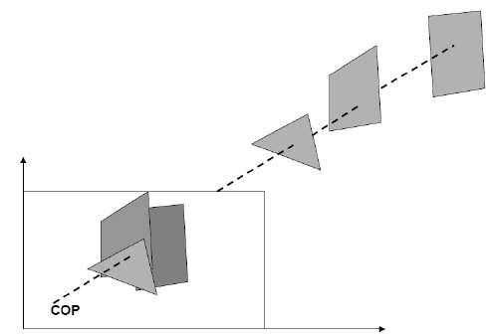
Algorithm

Step-1 − Set the buffer values −
Depthbuffer x,y
= 0
Framebuffer x,y
= background color
Step-2 − Process each polygon Oneatatime
For each projected x,y
pixel position of a polygon, calculate depth z.
If Z > depthbuffer x,y
Compute surface color,
set depthbuffer x,y
= z,
framebuffer x,y
= surfacecolor x,y
Advantages

• It is easy to implement.
• It reduces the speed problem if implemented in hardware.
• It processes one object at a time.

Disadvantages

• It requires large memory.
• It is time consuming process.

Scan-Line Method
It is an image-space method to identify visible surface. This method has a depth information for
only single scan-line. In order to require one scan-line of depth values, we must group and process
all polygons intersecting a given scan-line at the same time before processing the next scan-line.
Two important tables, edge table and polygon table, are maintained for this.
The Edge Table − It contains coordinate endpoints of each line in the scene, the inverse slope of
each line, and pointers into the polygon table to connect edges to surfaces.
The Polygon Table − It contains the plane coefficients, surface material properties, other surface
data, and may be pointers to the edge table.

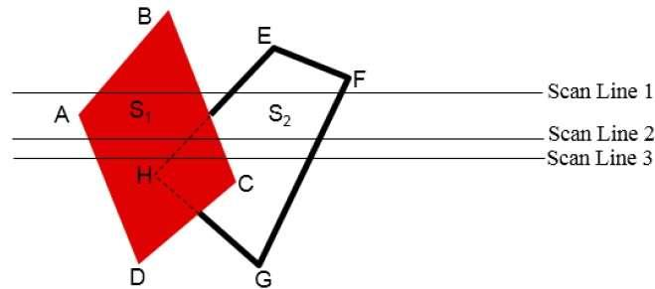

To facilitate the search for surfaces crossing a given scan-line, an active list of edges is formed. The
active list stores only those edges that cross the scan-line in order of increasing x. Also a flag is set
for each surface to indicate whether a position along a scan-line is either inside or outside the
surface.
Pixel positions across each scan-line are processed from left to right. At the left intersection with a
surface, the surface flag is turned on and at the right, the flag is turned off. You only need to
perform depth calculations when multiple surfaces have their flags turned on at a certain scan-line
position.
Area-Subdivision Method
The area-subdivision method takes advantage by locating those view areas that represent part of a
single surface. Divide the total viewing area into smaller and smaller rectangles until each small
area is the projection of part of a single visible surface or no surface at all.

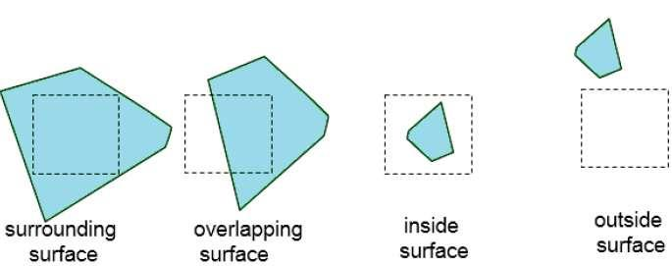
Continue this process until the subdivisions are easily analyzed as belonging to a single surface or
until they are reduced to the size of a single pixel. An easy way to do this is to successively divide
the area into four equal parts at each step. There are four possible relationships that a surface can
have with a specified area boundary.

• Surrounding surface − One that completely encloses the area.
• Overlapping surface − One that is partly inside and partly outside the area.
• Inside surface − One that is completely inside the area.
• Outside surface − One that is completely outside the area.

The tests for determining surface visibility within an area can be stated in terms of these four
classifications. No further subdivisions of a specified area are needed if one of the following
conditions is true −

• All surfaces are outside surfaces with respect to the area.
• Only one inside, overlapping or surrounding surface is in the area.
• A surrounding surface obscures all other surfaces within the area boundaries.

Back-Face Detection
A fast and simple object-space method for identifying the back faces of a polyhedron is based on
the "inside-outside" tests. A point x,y,z
is "inside" a polygon surface with plane parameters A, B, C, and D if When an inside point is along
the line of sight to the surface, the polygon must be a back face we are inside that face and can not
see the front of it from our viewing position.
We can simplify this test by considering the normal vector N to a polygon surface, which has
Cartesian components A,B,C
In general, if V is a vector in the viewing direction from the eye or"camera"
position, then this polygon is a back face if
V.N > 0
Furthermore, if object descriptions are converted to projection coordinates and your viewing
direction is parallel to the viewing z-axis, then −
V = (0, 0, Vz) and V.N = VZC
So that we only need to consider the sign of C the component of the normal vector N.
In a right-handed viewing system with viewing direction along the negative ZV
axis, the polygon is a back face if C < 0. Also, we cannot see any face whose normal has z
component C = 0, since your viewing direction is towards that polygon. Thus, in general, we can
label any polygon as a back face if its normal vector has a z component value −
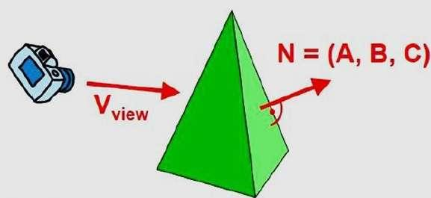
C <= 0

Similar methods can be used in packages that employ a left-handed viewing system. In these
packages, plane parameters A, B, C and D can be calculated from polygon vertex coordinates
specified in a clockwise direction unlike the counter clockwise direction used in a right−handed
system.
by C >= 0 when the viewing direction is along the positive Zv
axis. By examining parameter C for the different planes defining an object, we can immediately
identify all the back faces.

